# Project Book

## Mapping Displacement

For the mapping portion of our project, we initially looked at yearly maps of asylum seekers. However, it didn’t look like there was clear information that would have been helpful, so we decided to make a map for all years combined (since 1961). Below are some initial maps we looked at:

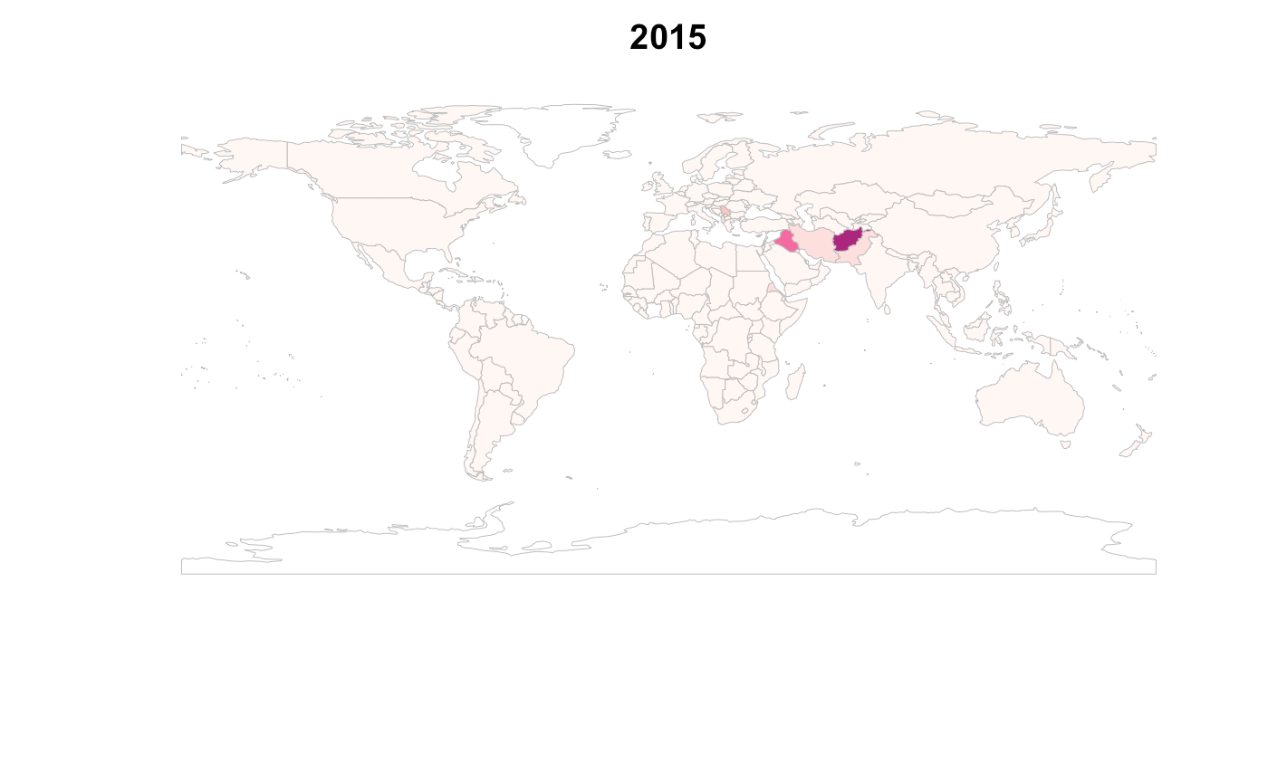

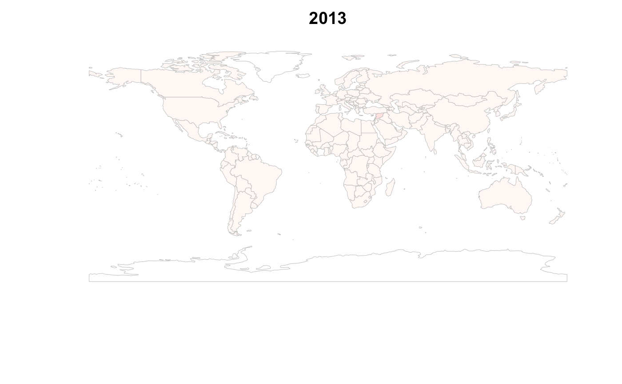

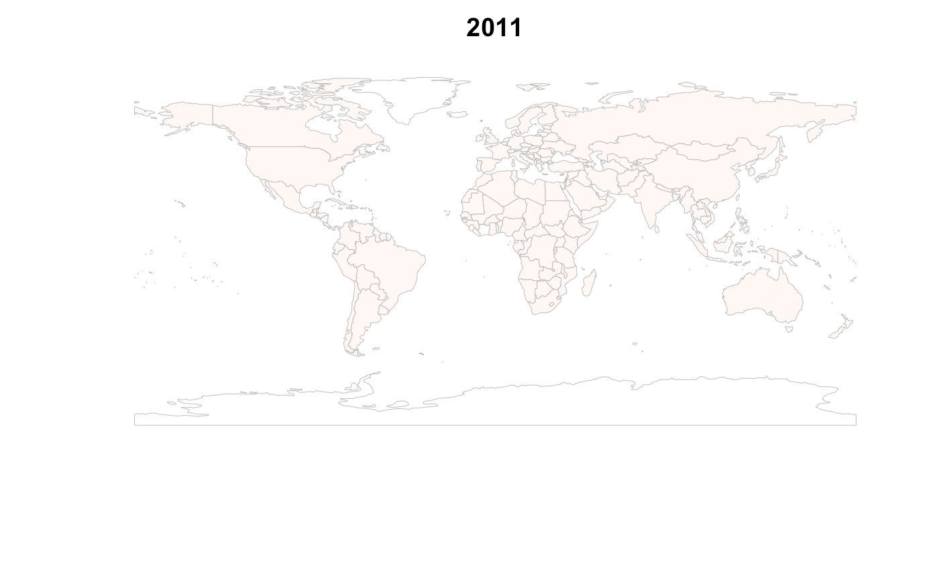

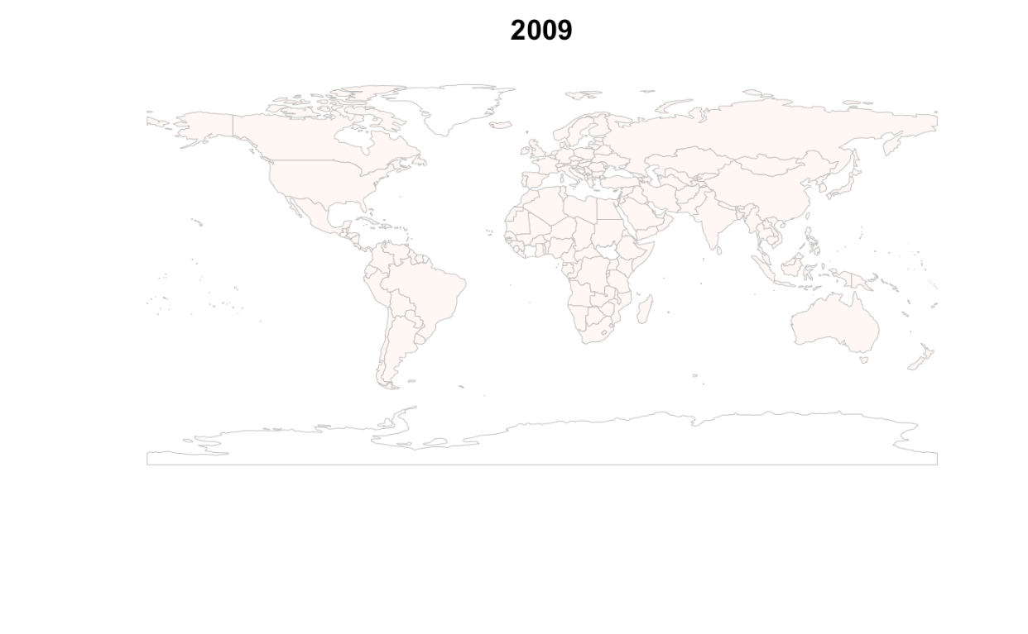

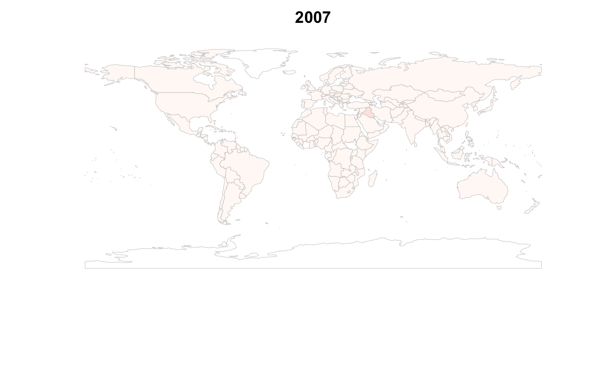

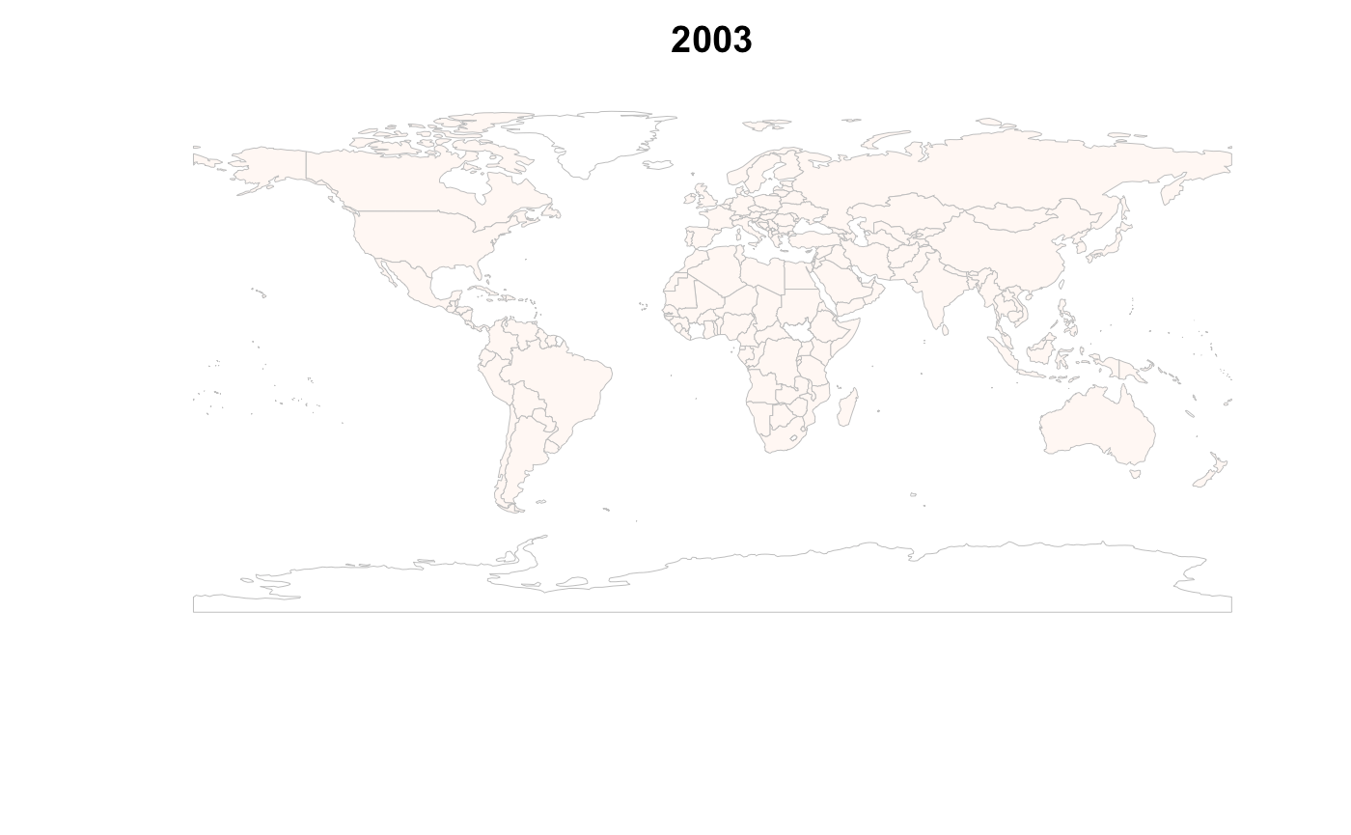

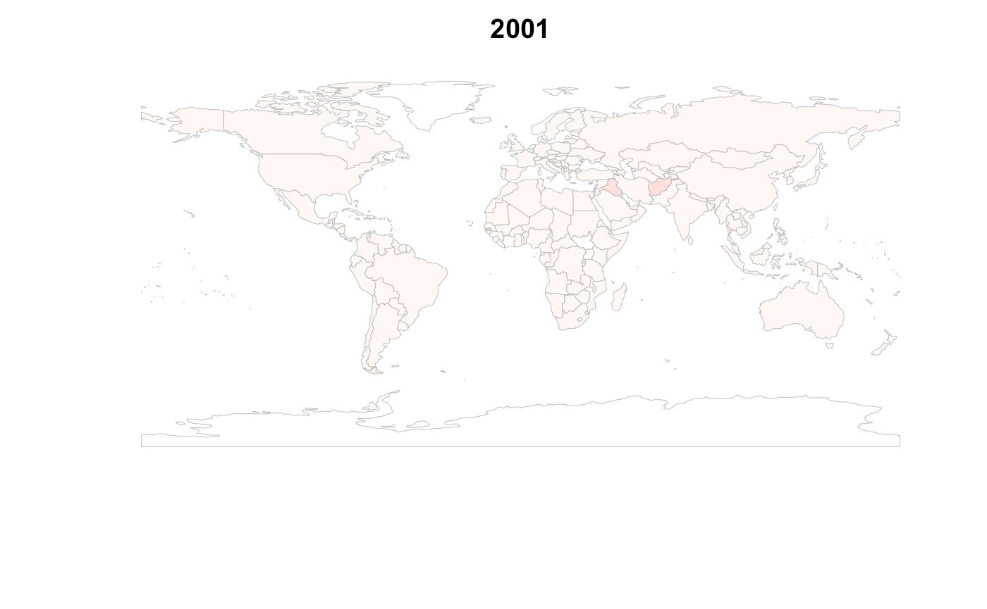

## Regression – Scatter Plots

We also ran several regressions looking at the relationship between asylum-seekers and GDP, percentage change in GDP, cereal yield, and percentage change in cereal yield. However, we didn’t think they were saying anything specific, so we decided to keep the explanations of what is driving migration exploratory. Below are the plots we made based on these regressions:

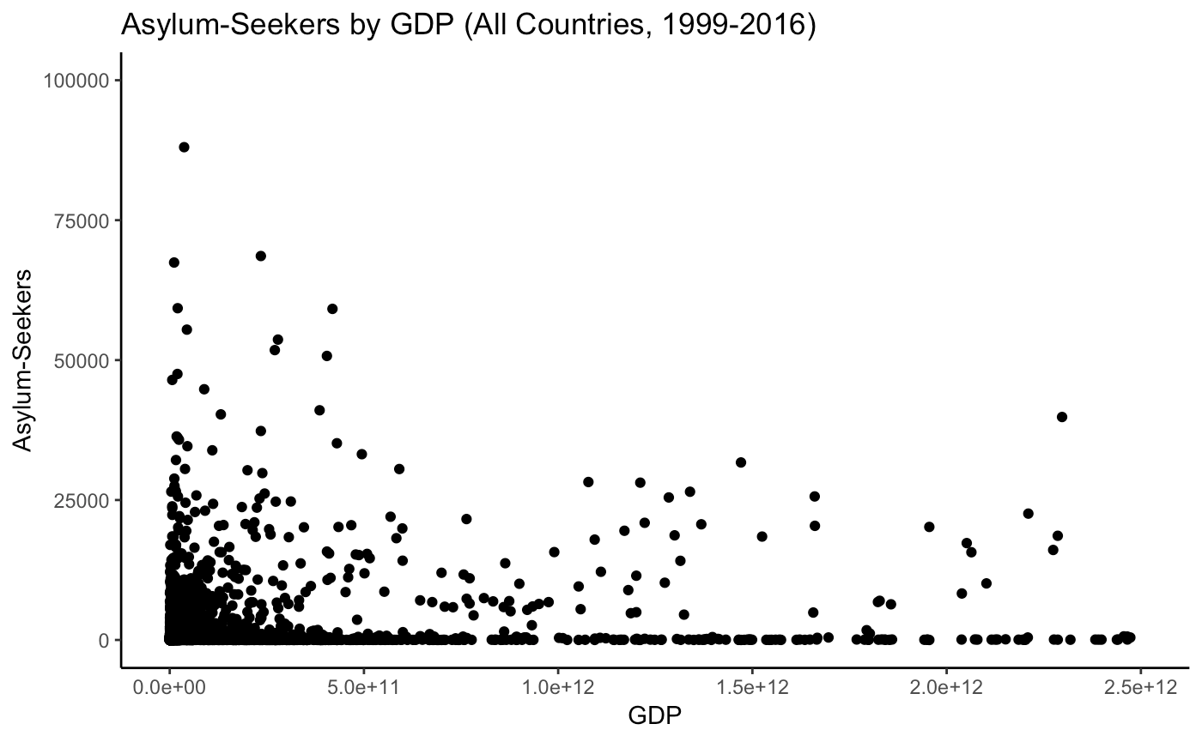

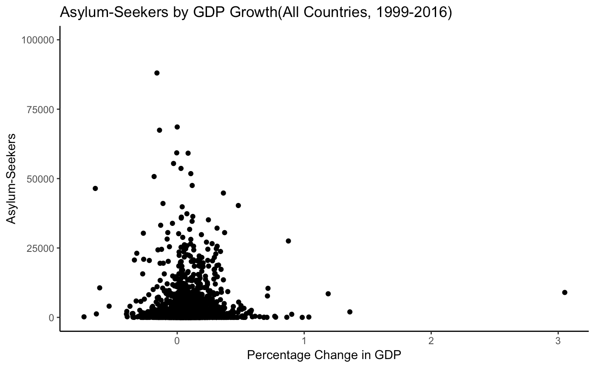

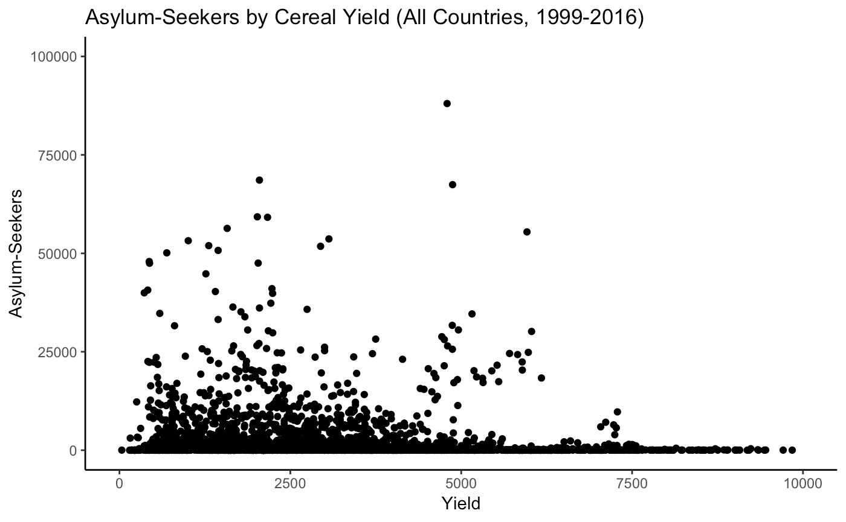

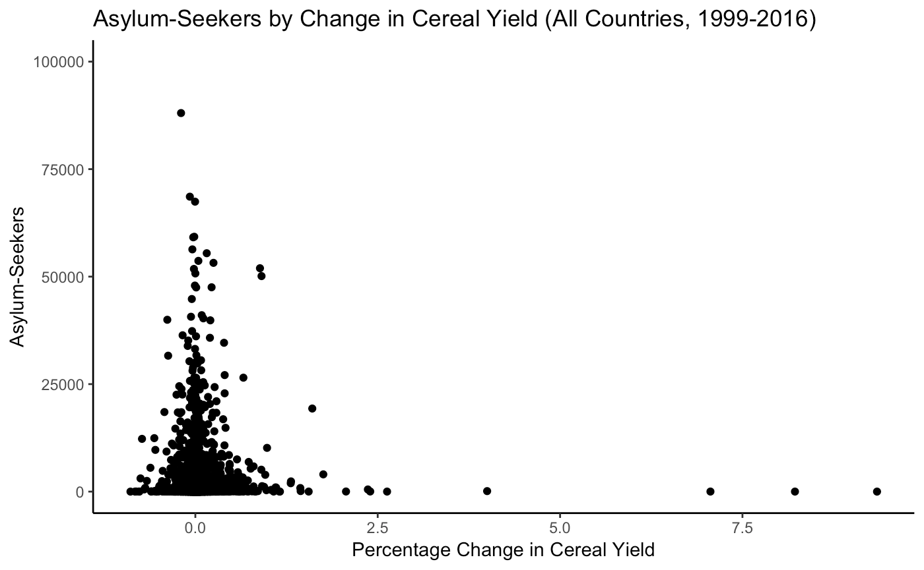

## Asylum Seeker Line Graphs

We also made some line graphs of where asylum seekers were going as their destination country. However, this became messy with the number of countries involved, so we did not go this route.

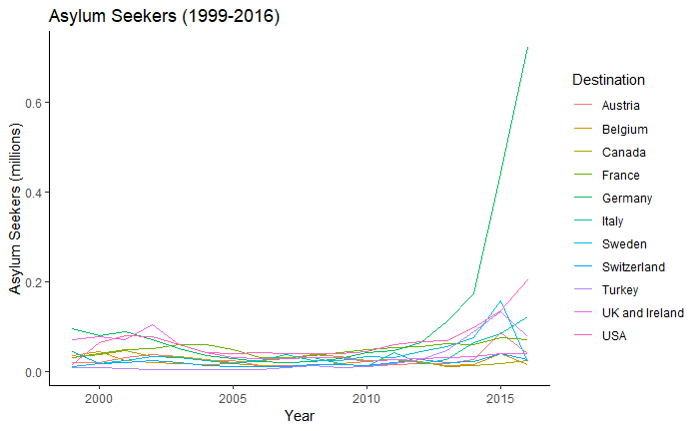

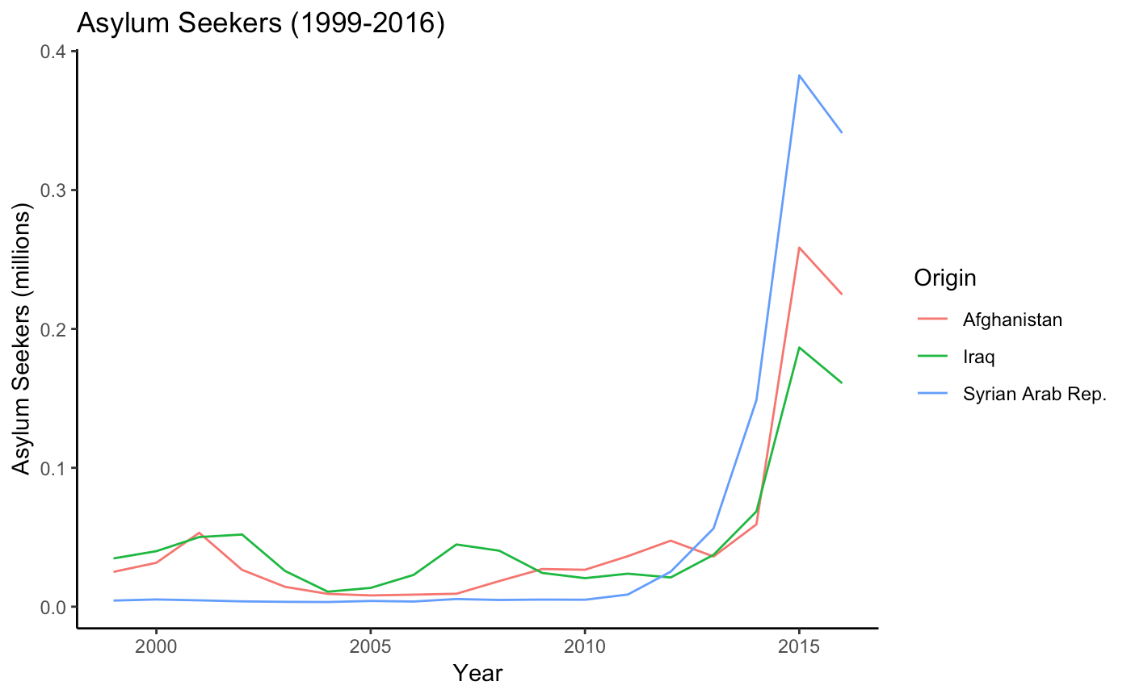

## Rainfall and Displacement

Initially, we also wanted to plot rainfall levels versus refugee or internally displaced persons to look at how rainfall has affected displacement in different countries. We made the following two line plots, which seem to indicate that those countries with the highest numbers of refugees and internally displaced people are all countries where there is very little rainfall (indicated by the small size of the circles). However, all the other countries at the bottom of the graph are all cluttered together and in the end, we did not have time to explore this further and try to make this more presentable.

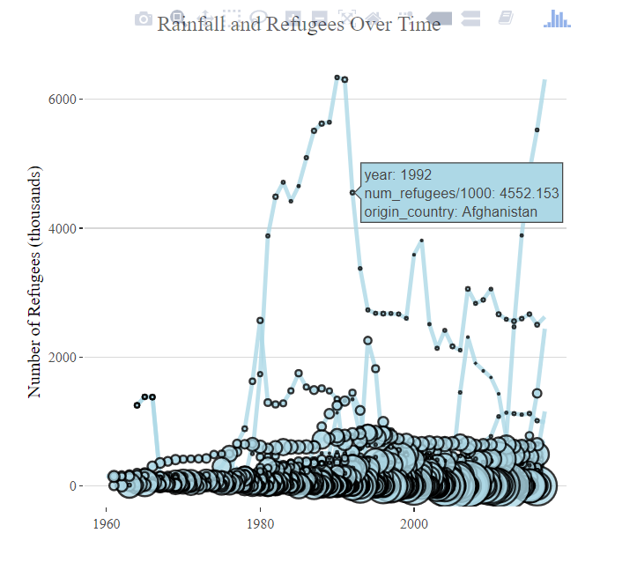

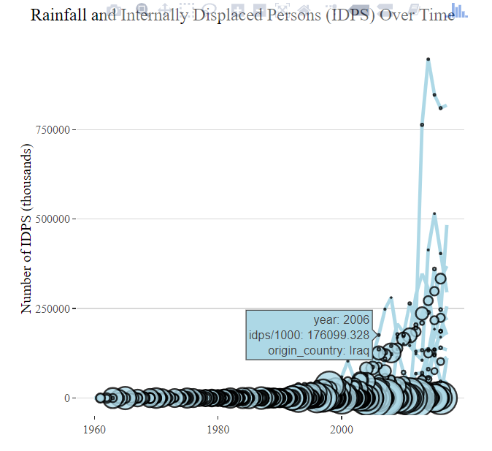

## Political Stability and Displacement

Initially, we wanted to plot political stability versus refugee or internally displaced persons to look at how this has affected displacement in different countries. We made the following two line plots, which seem to indicate that many countries with the highest numbers of refugees and internally displaced people are all countries where there is very little political stability (indicated by the small size of the circles). However, all the other countries at the bottom of the graph are all cluttered together and in the end, we did not have time to explore this further and try to make this more presentable.

